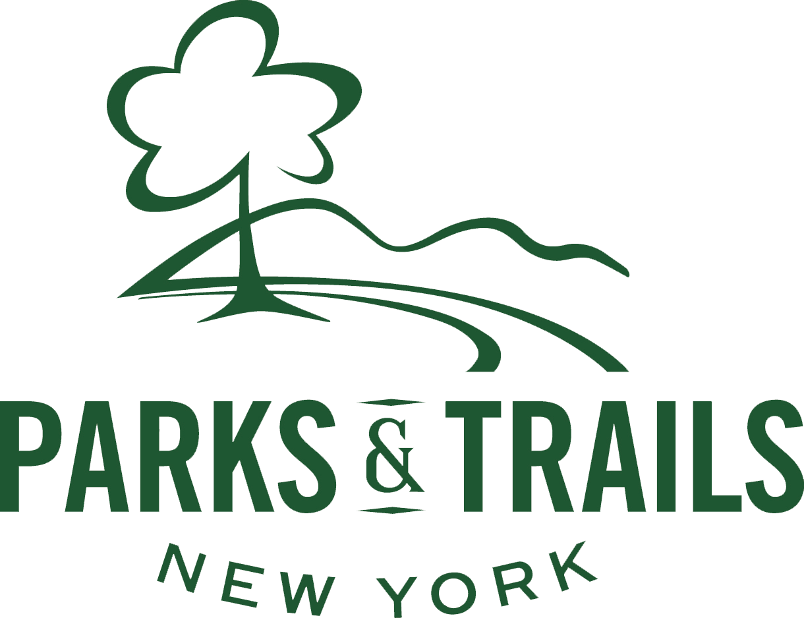

Organizational Self-Assessment & Visioning Tool

Introduction
This tool is designed to help Friends groups assess their organizations’ governance, programs, financial management, and communications, as well as to think about where Board members/staff think the organization should be in a few years. The tool will also foster healthy discussion and provide a roadmap to future evaluations.

How to Complete the Self-Assessment & Visioning Tool
For Step-up Grant recipients
When using this tool as part of a NYS Park and Trail Partnership Program Step-up Grant, organizations must engage with an independent consultant to facilitate the organizational assessment. Following the facilitated assessment, the consultant should prepare a report and plan(s) to guide the next steps for the organization based on the results of the assessment.

For all other organizations
If using this tool outside of the grant process, there are several options for how your organization can complete this form. In all cases, the assessment should be completed by more than one member of the Friends group.

- Complete the assessment as a group: Completing this form as a group—and coming to consensus on how you rate each item—can open up avenues of discussion. It can be completed by the entire board at an upcoming meeting or a subset or committee of the board assigned to work on it.

- Hand out the assessment to be completed at a board meeting: This way, individuals can rank items based on personal opinions. Alternatively, an electronic version of the form can be sent to board members. The results can then be tallied by the Friends group.

- Conduct a consultant-led organizational assessment: An independent consultant may be engaged to facilitate a meeting (or multiple meetings) during which the organization is led through the self-assessment and visioning tool. The consultant may also prepare a report and plan(s) to guide the next steps for the organization based on the results of the assessment.

Be as honest as possible in your responses as it will greatly aid the process.

NAME OF ORGANIZATION: ______________________________________ DATE: ________

MISSION & PROGRAMS | Strongly Agree | Agree | Uncertain / Neutral | Disagree | Strongly Disagree | Notes
Our organization has a clearly written mission statement.
Board members are able to clearly articulate the mission of the organization.
Our organization has an MOA with OPRHP.
Our organization has a good working relationship with park/site staff.
Our organization regularly hosts programs and/or completes service projects at the park/site.
Our programs are successful and well attended.
Our organization would like to host more or different programs at the park/site.
PLANNING & EVALUATION | Strongly Agree | Agree | Uncertain/Neutral | Disagree | Strongly Disagree | Notes
Our organization has engaged in some type of formal planning in the past 3 to 5 years.
Our organization recognizes and understands its current strengths, weaknesses, opportunities and threats.
We regularly evaluate our programs.
New ideas are welcomed in our organization.
BOARD GOVERNANCE | Strongly Agree | Agree | Uncertain/Neutral | Disagree | Strongly Disagree | Notes
Our organization has articles of incorporation and bylaws that are clearly written.
Someone on the board is aware of the legal requirements of charitable organizations at federal, state, and local levels and ensures compliance.
The board meets regularly, board meetings are well attended, and meeting minutes are recorded.
Board members are aware of their roles and responsibilities; new board members receive orientation to the organization.
The board reflects the diversity, ethnicity, and educational and economic status of the community.
Board members get information far enough in advance of a meeting to fully review beforehand (i.e., agendas, minutes, financial reports, other materials to be considered at a meeting, etc.)
The board has active committees.
We have enough active board members to accomplish our work.
Board members attend Friends and park/site events.
We would like additional expertise and diversity on our board.

If agree or strongly agree, please indicate what skills/expertise/representation you would like on the board:

CAPACITY | Strongly Agree | Agree | Uncertain/Neutral | Disagree | Strongly Disagree | Notes
Our organization has sufficient volunteers, staff and/or consultants to carry out its work.
Our organization has a system for recruiting, training and recognizing volunteers.
If organization does not currently have staff:
Our organization would like to hire staff someday.

FINANCIAL MANAGEMENT | Strongly Agree | Agree | Uncertain/Neutral | Disagree | Strongly  Disagree | Notes
Our organization prepares an annual budget which includes all expected revenues and expenses.
For organizations with budgets over $50,000:
Our organization’s finances are reviewed annually by a CPA or other individual, preferably not members of the board.
Our organization prepares regular financial statements [Balance Sheet (assets and liabilities), Statement of Activities (income and expenses), and Statement of Cash Flows].
Current assets are greater than current liabilities.
All required forms and reports are filed on time with the
IRS and NYS.
FUNDRAISING | Strongly Agree | Agree | Uncertain/Neutral | Disagree | Strongly  Disagree | Notes
Board members are expected to make meaningful financial contributions and are actively involved in seeking and securing funds for the organization.
Our organization regularly engages in fundraising as part of its activities.
Our organization has a diverse mix of earned income (membership, ticket sales, subscriptions, concessions) and unearned income (grants, gifts, contributions).
Our organization has sufficient funding to cover operating costs each year.
Our organization raises funds for park/site projects.
A system is in place for tracking past, current and potential donors and members.
A donor recognition system is in place.
COMMUNICATIONS/  PUBLIC RELATIONS | Strongly Agree | Agree | Uncertain/Neutral | Disagree | Strongly  Disagree | Notes
Our organization has an effective system for informing the community about events and programs.

Please list the current communications channels used to inform the community about events and programs:

Our organization has a mailing list that is accurate and updated regularly.
Our organization has an updated list of media contacts and regularly forwards press releases to them.
Legislative representatives and local government officials are included on the organization’s mailing list and are regularly invited to events.
Our organization has a wide circle of contacts from the community that it can call on for support, including bankers, lawyers, government officials, business community, accountants, other nonprofits, consultants, etc.
Our organization would like to develop strategies to broaden and diversify participation in our programs.

VISION FOR THE FUTURE

Please list up to five things you would like to see the organization achieve in the next 3 to 5 years. The list does not have to be exhaustive and it can be broad or specific, small or big – there are no right or wrong answers!

Some examples might be: we’d like to grow our board to 20 members; be a resource to the local community; grow our membership by 50%; host a successful annual fundraising event; complete a capital fundraising campaign for the park; ensure board sustainability; build partnerships with other nonprofits; etc.
This tool adapted from the Massachusetts Cultural Council’s Organizational Self-Assessment Tool.

