Appendix G: Template Certificate for Sponsors

Certificate of Appreciation
Awarded this 7th day of May 2022 to:

Place Name of Business Partner Here

For their support and sponsorship of I Love My Park Day
at YOUR PARK/SITE NAME
to help restore and beautify New York State Parks
and Historic Sites for all to experience and enjoy.

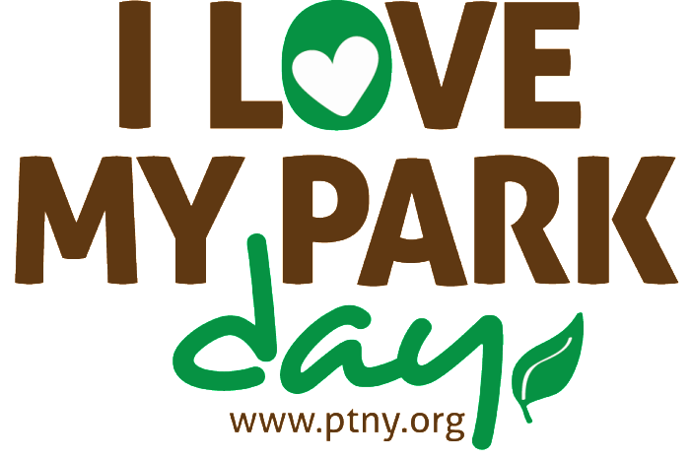

Place Your Logo Here

Friends Representative Name

