Certificate of Participation
Awarded this 1ST day of May 2021 to:

For their support and sponsorship of I Love My Park Day
at YOUR PARK/SITE NAME
to help restore and beautify New York State Parks
and Historic Sites for all to experience and enjoy.

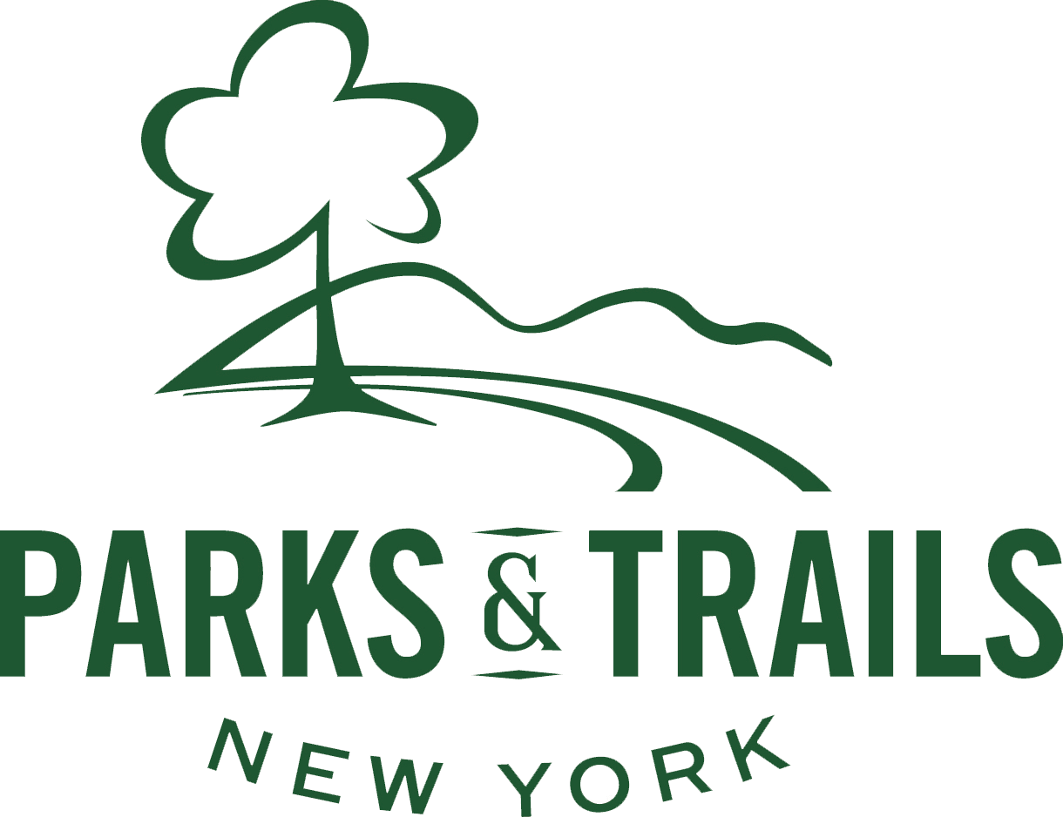
Park Staff Name & Title

