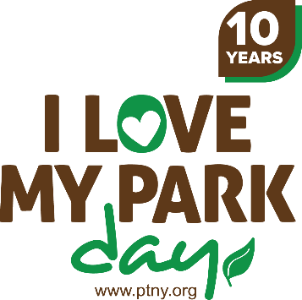

Day-of Checklist
- Important phone numbers
  - Committee members
  - Park manager
  - Vendors
  - Speakers
  - Volunteers
  - Media contacts
  - Emergency numbers
- Signs
- Table(s)
- Watch
- Clipboards
- Megaphone or PA system
- Poster
- Cleanup/improvement tools and equipment
- First-aid kit
- Refreshments
- I Love My Park Day bandanas and other promotional items
- Membership brochures and copies of recent newsletter
- I Love My Park Day fact sheet
- Friends email list sign-up sheets
- Project sign-up sheets
- Volunteer handouts or packets
- Pens and markers
- Tape
- Extra copies of Volunteer Service Agreement
- Extra copies of Photo Release forms
- Camera
- Press kits

