Appendix G: Template Certificate for Sponsors

Awarded this 5th day of May 2018 to:

Place Name of Business Partner Here

For their support and sponsorship of I Love My Park Day
at YOUR PARK/SITE NAME
to help restore and beautify New York State Parks
and Historic Sites for all to experience and enjoy.

Place Your Logo Here

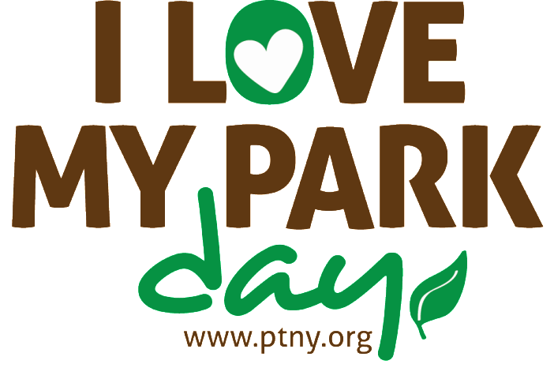

Friends Representative Name Title

