Template I LOVE MY PARK DAY Flyer

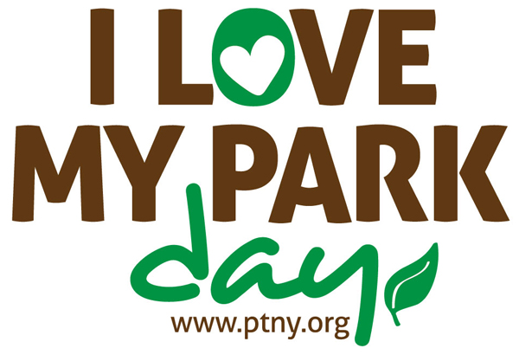

Show New York’s State Parks Some Love
Saturday May 7th, 2022

Volunteer on May 7 and be a part of this exciting statewide event to improve and enhance New York’s state parks and historic sites and bring visibility to the entire state park system.
Your Park Name Here
WHEN: Saturday, May 7
TIME:
LOCATION:
PROJECT DESCRIPTION:
MORE INFO: (phone number)
Register to volunteer at
www.ptny.org/ilovemypark

